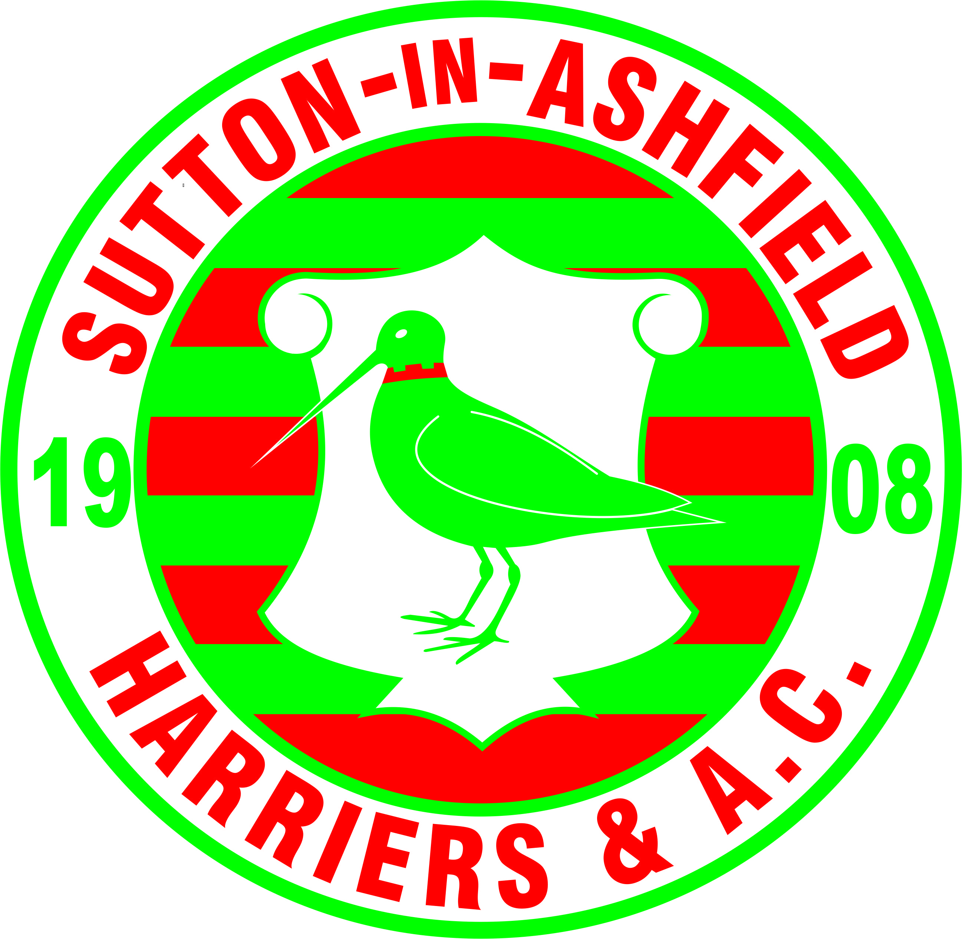

Sutton-in-Ashfield Harriers & Athletic Club
Founded 1908
Web site – http://www.sutton-in-ashfield-harriers.co.uk

Minutes of Committee Meeting 23/09/19

- Members Present
Paul Whittingham, Sue Chillingworth, Phill Bird, Julie Mitchell, Jordan Mitchell, Conrad Watson, Claire Watson, James Simpson Paul Beasley

Apologies for Absence Helen Burnham, Nick Burnside

Minutes of the Previous Meeting Accepted,

- Matters Arising
Jordan has not yet purchased a pole vault bag
Silver plate trophy, not been worked on yet
Equipment list continually ongoing – people to alert committee when anything is worn
Phil had info back regarding club crest for vests. Its ok for us to have one, so committee decided it would be put on all new vets and try to get it put on the existing ones we have in stock. All in favour for It to be positioned in the centre, chest level.
Paul W showed us a new club vest, in a different material, very light and silky. Julies concerns was for the younger ones, so Paul will have a word with the supplier to see if he has something else for them, just a little less flimsly.

Correspondence
Sue sent out correspondence, Tracey Parker is now wanting to move onto the next coaching level. This was agreed for her to do so.

- Treasurers Report

- New Members
Neve Hollingworth, Maddy Smith, Matt Frost. Frost Family ( Harvey, Henry, Archie, Issac) & Cole Beck

- Delegates Reports
Sent out, Clare has one other that will be on the next minutes

- AOB

Sue – Presentation evening
Medals – pre ordered, athletes to let us know if they have reached the standards for RR
Tombola prizes required
Tickets been printed and will now go on sale £8 Adult, £30 Family#
All committee to bring cakes on the afternoon of setting up, if not available for this, then give to someone else to bring
Suggested next year that the club would pay for the engraving of trophies if athletes required this
Athletes money will be awarded to Iris Clarke & Cameron Turner
Paul W to ask Luke Wigman again to present on the evening
Photographer will be David Allcock

Julie
Rushcliffe have dropped out of our composite YDL U/17 & U/20 team. Just leaves Mansfield and us.

Phill
Suggested we give out service medal, bronze silver & gold to various people oat the club. These will be given to John Knight, Mick Moakes & Mick Davies this year.

Claire
Claire offered her services in place of Tracy Parker with the youngster’s group. She is also interested in going on a coaching course to help in this group. Sue to send her details.

Conrad
Helen Burnham sent a letter via Conrad to be read out at this meeting, it was regarding an incident between Herself, Ben and Harold. The committee sat and listened.

Next Meeting 28th October 2019 6.45pm

